XF
2025 Aug
- How to install the application of Production line(https://appprod.inteplast.com - /appProduction/XF/)
- Coextrusion（Do Not Install The printer of the production line）
https://appprod.inteplast.com - /appProduction/XF/CoExtrusion/
If you change the label printer, please set the same static IP:
Area | Label printer IP
Coex | 172.17.30.91

- Spiral-Cut（Do Not Install The printer of the production line）
https://appprod.inteplast.com - /appProduction/XF/SpiralCut/
If you change the label printer, please set the same static IP: 172.17.30.92
Area | Label printer IP
Spiral-Cut | 172.17.30.92

- Stretch-Lamnation（Do Not Install The printer of the production line）
https://appprod.inteplast.com - /appProduction/XF/StretchLamination/
If you change the label printer, please set the same static IP: 172.17.30.93
Area | Label printer IP
Stretch-Lamnation | 172.17.30.93

- G-Laminator（Do Not Install The printer of the production line）
https://appprod.inteplast.com - /appProduction/XF/GLaminator/
If you change the label printer, please set the same static IP: 172.17.30.94
Area | Label printer IP
G-Lamnation | 172.17.30.94

- Slitting （Do Not Install The printer of the production line）
https:// appprod.inteplast.com - /appProduction/XF/Slitting/
If you change the label printer of HA 12&13(Large), please set the same static IP:
Area | Label printer IP(Large) | Label printer IP(Small)
HA 12&13 | 172.17.30.167 | 172.17.31.65
HA 14 | 172.17.30.97 | 172.17.30.96
HA 15 | 172.17.30.98 | 172.17.30.99

- Shipping
https://appprod.inteplast.com - /appProduction/XF/Schedule/
If you change the label printer, please set the same static IP: 172.17.30.55
Area | Label printer IP
Shipping area | 172.17.30.55

- Edge-Lamination
https://appprod.inteplast.com - /appProduction/XF/EdgeLamination/
If you change the label printer（Large）, please set the same static IP:
Area | Label printer IP(Large) | Label printer IP(Small)
Edge-Lamination | 172.17.30.103 | 172.17.30.102

- Printing
https://appprod.inteplast.com - /appProduction/XF/Printing/
If you change the label printer, please set the same static IP:
Area | Label printer IP(Large) | Label printer IP(Small)
Printing | 172.17.30.101 | 172.17.30.100

How to download the “setup.exe” file for the each application.(Steps)
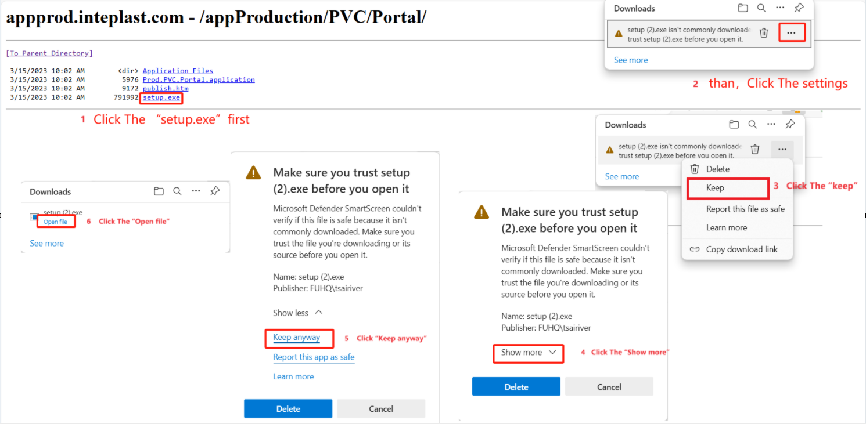
Install the application steps.
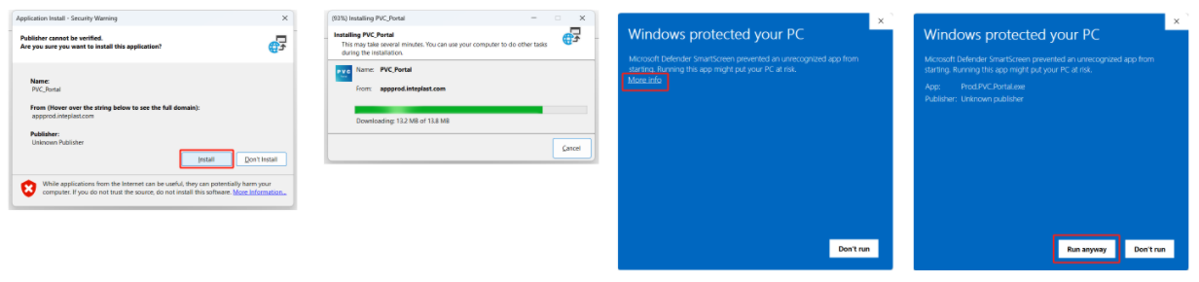
Teamviewer information of the Production Line’s Mini PC:

- IT Support For Office
I only have access to the “Software” folder on the XF’s NAS; Username: cyber

- For new computer in the XF office :
Install the AS400 and Anti-viruse
Login to XF’s NAS \\172.17.25.100\

Username: cyber
Password: softwareteam

Install the Anti-Virus
\\172.17.25.100\Software\Cyber\WPJK Anti-Virus\cmd.bat
Run the batch file(cmd.bat)
Install the AS400 steps
\\172.17.25.100\Software\Cyber\AS400（New Version）
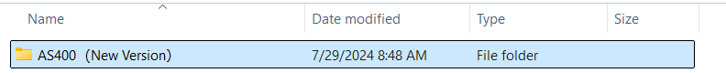
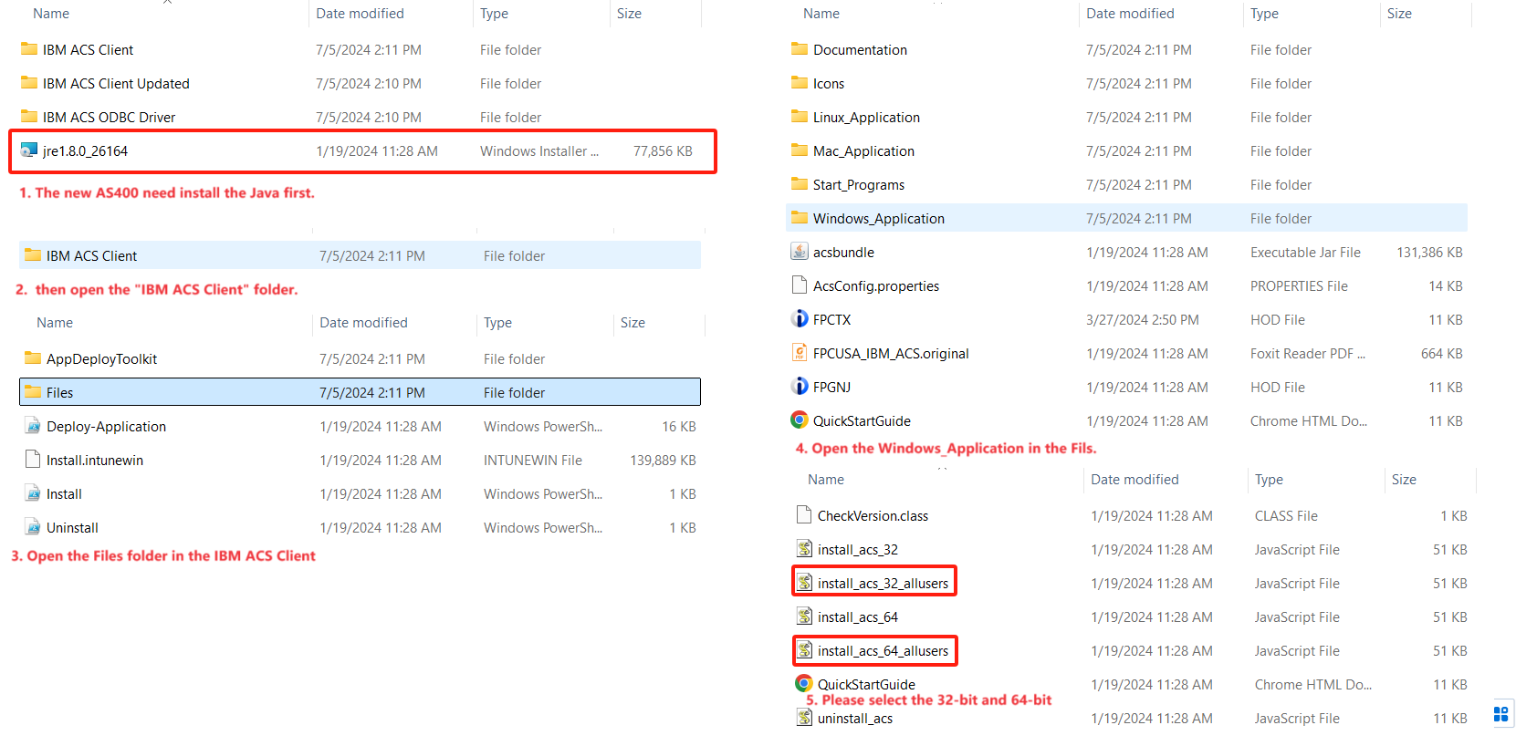
After install the AS400, please copy the “FPCTX.hod” icon copy and paste to the user’s desktop.
\\172.17.25.100\Software\Cyber\AS400（New Version）\IBM ACS Client\Files\FPCTX.hod
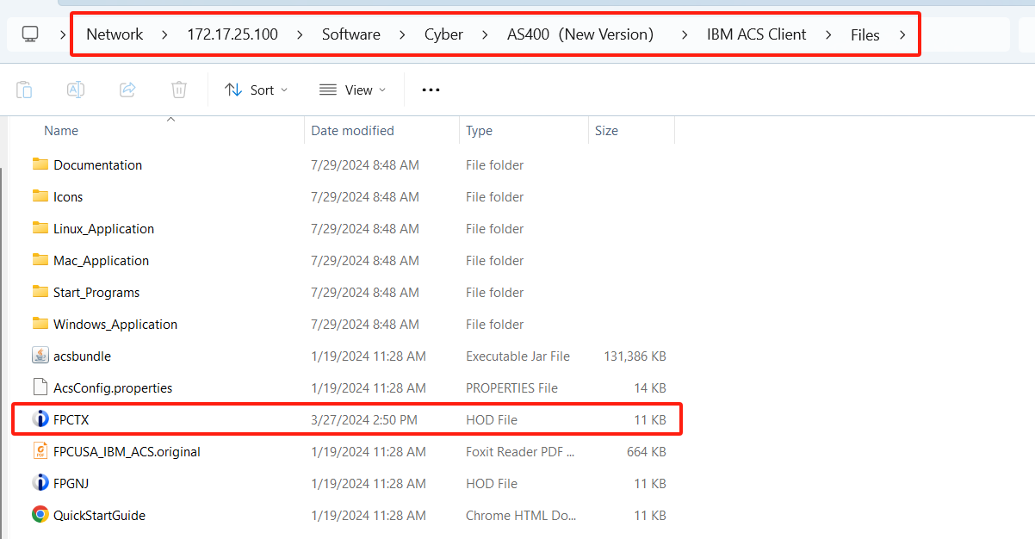

- Plant Management for Supervisor
https://appprod.inteplast.com - /appProduction/XF/PlantMgt/
The install steps, see the same with production line.
- Product line Scheduling(For Feifei Chou)
https://appprod.inteplast.com - /appProduction/XF/Scheduling/
The install steps, see the same with production line.

- Install and connect the Kyocera printer for office user
https://youtu.be/F_pz6BIsRXY
https://youtu.be/hCYFL-8s914

- Setup the email account of copy machine.(IP: 172.17.24.80)
Username: Service@wpjk.inteplast.com
password: Bom07544

- WIFI information
WIFI of XF Office：
Router mode: AP mode
IP address: 172.17.26.128(DHCP)
URL: http://www.routerlogin.net/
SSID: NETGEAR94
Password: fuzzyviolin497
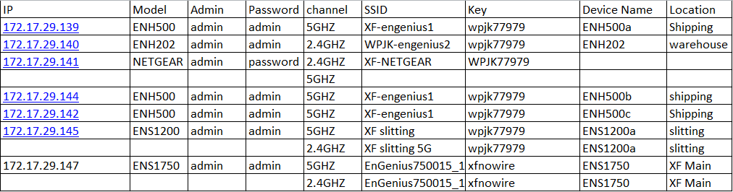

- XF plant map
The yellow line is the fiber optic.
The blue line is the Ethernet cable.
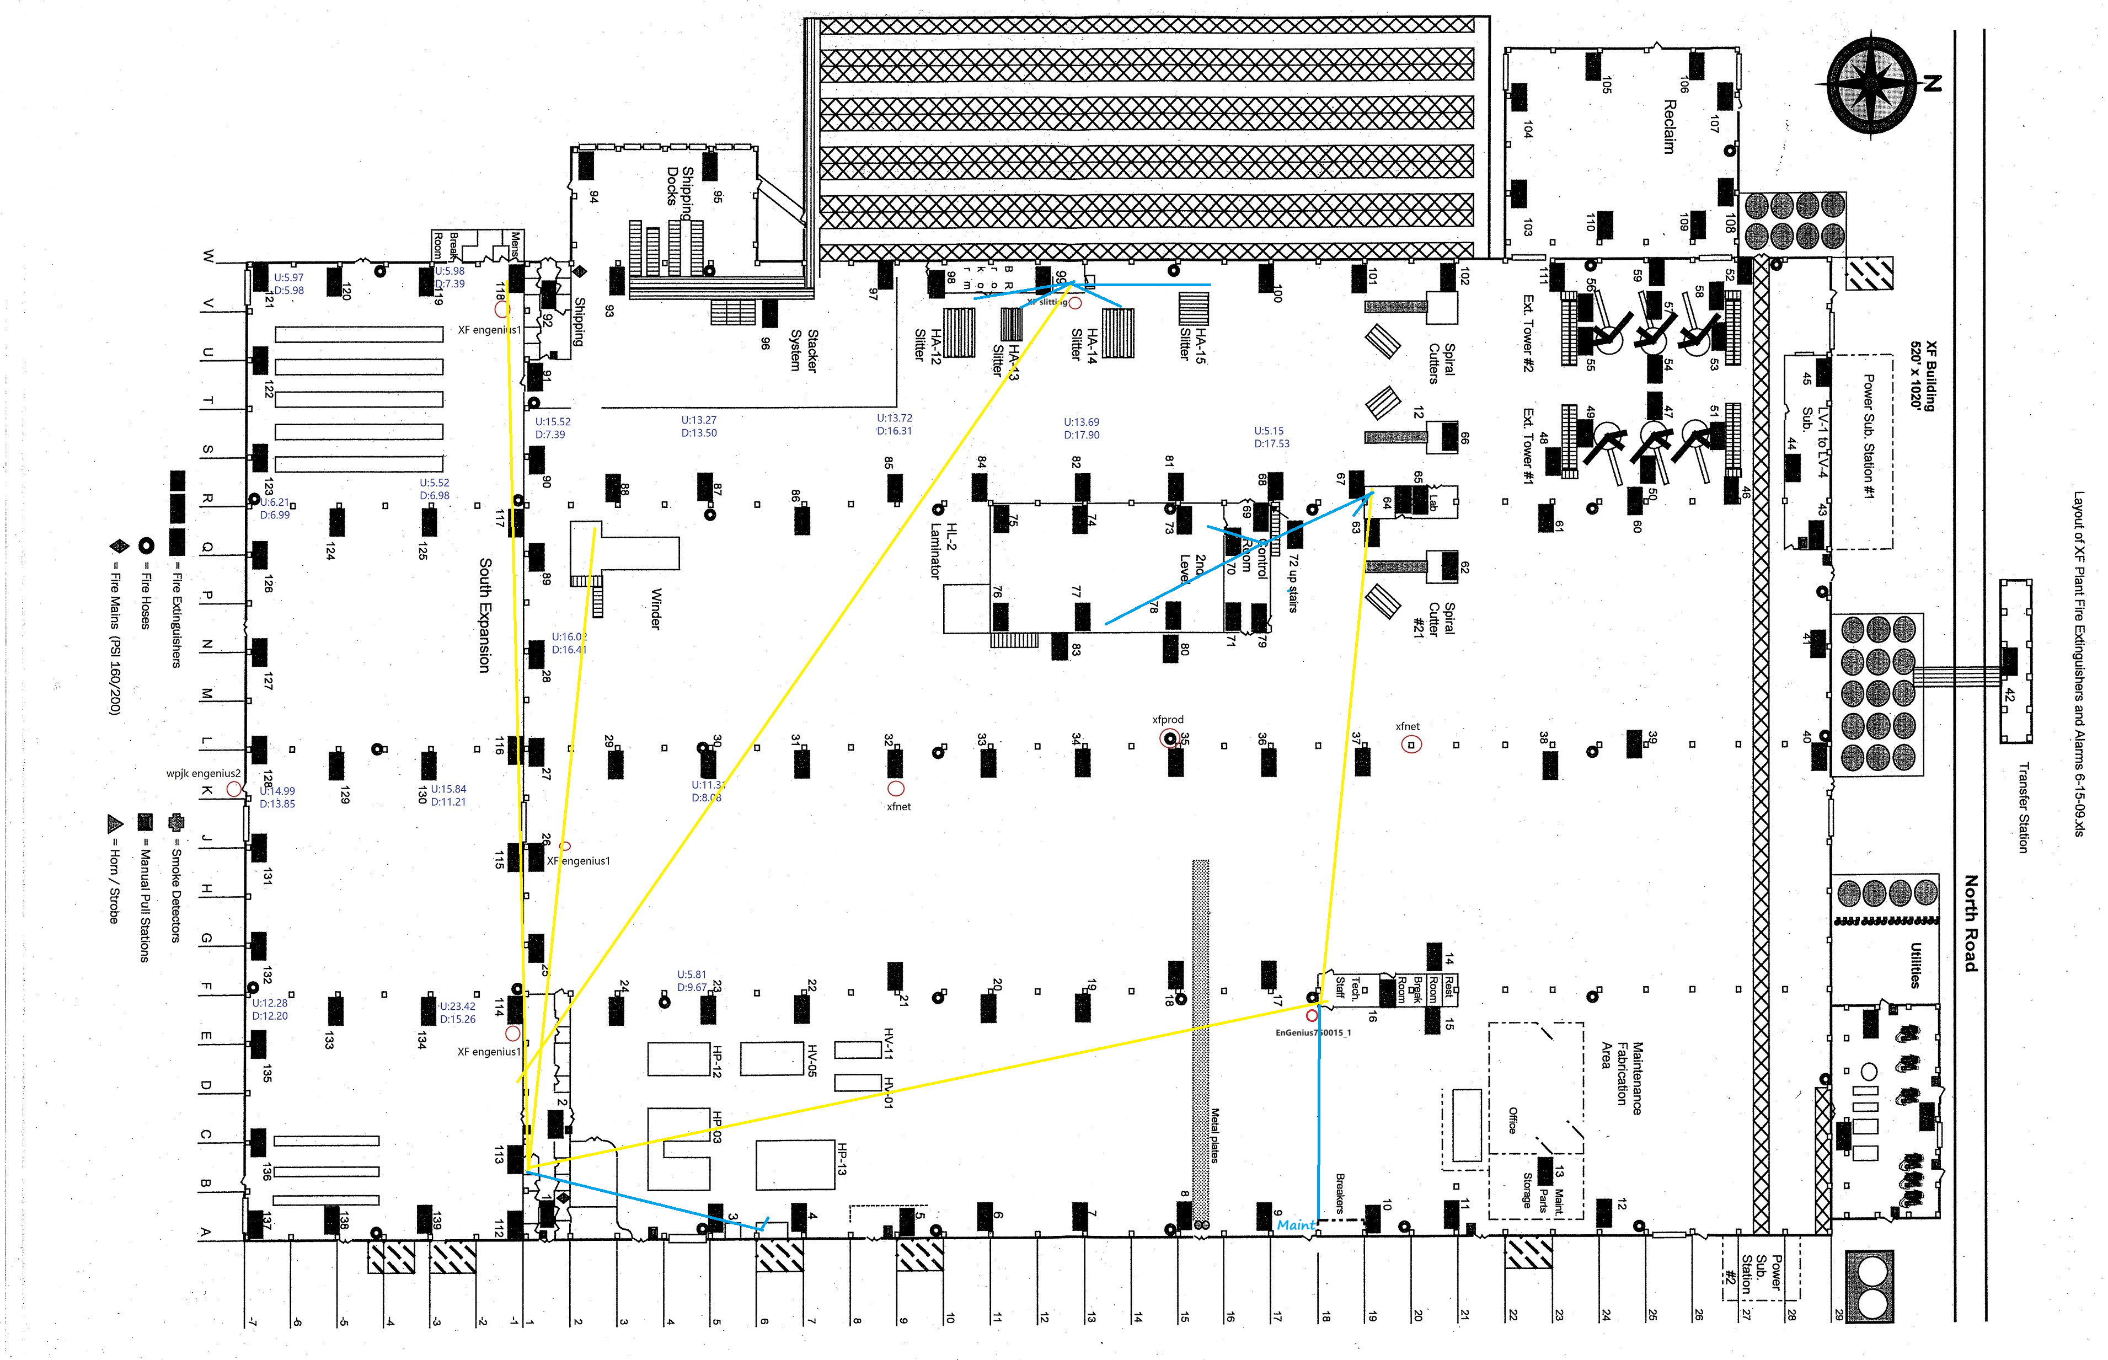

- Fixed IP of XF
172.17.24.80 copy machine in the office
172.17.25.100 NAS in the maintenance office
172.17.27.10 QC query server

